**USER MANUAL**

**CORTEX M3 NXP-LPC1768**

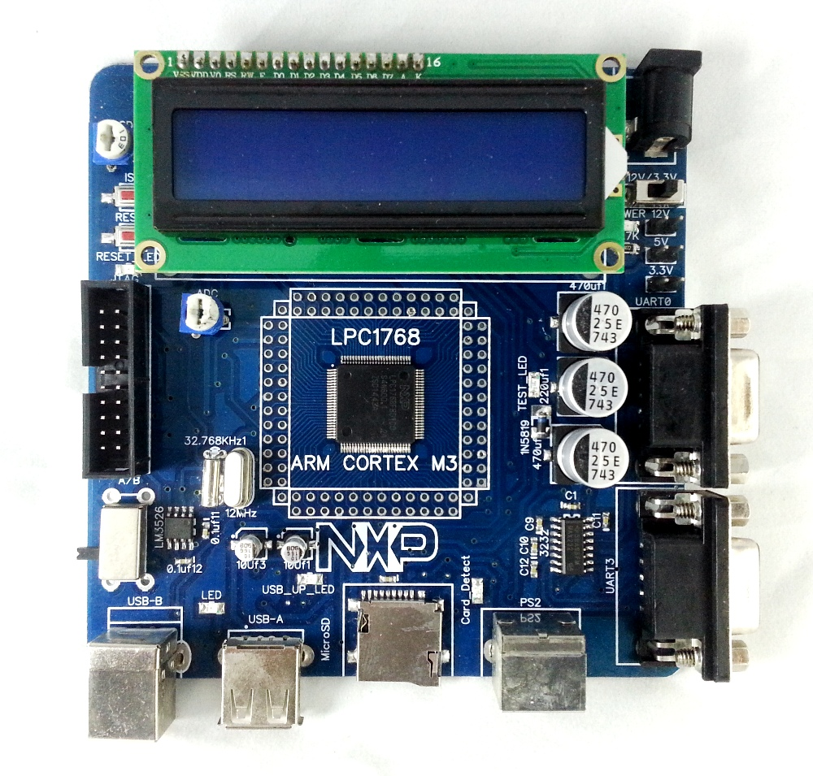

**Table of Contents:**

1. INTRODUCTION & LPC1768 BOARD FEATURES
2. SYSTEM REQUIREMENTS
3. STARTING OFF & CONNECTING THE HARDWARE
4. PROGRAMMING LPC1768 Board
5. FUNCTIONAL OVERVIEW
6. HARDWARE CONFIGURATIONS
7. OVERVIEW
8. SCHEMATICS
9. SAMPLE APPLICATIONS.

**1: INTRODUCTION & LPC1768 Board Features:**

Blue Board- LPC1768 is an evaluation board for LPC1768 CORTEX M3 based microcontroller. The LPC1768 microcontroller has 512KB of internal flash and 64KB SRAM. Following are the salient features of the board.

* Dimensions: 106 X 108 mm2
* Two layer PCB (FR-4 material)
* Power supply: DC 9V with power LED
* On-board linear regulators generate +3.3V/500mA and +5v/500mA from power supply.
* USB connector (as alternate power source).
* Connectors:

Extension headers for all microcontroller pins. RS232 connectors (2).

PS/2 connector. JTAG connector.

SD/MMC connector.

USB A-Type USB B-Type connector with Link-LED.

* Other Peripherals:
* 2 line X 16 character LCD with back light control.
* Configurable for manual and automatic program download (ISP) via serial port. User Interrupt, ADC, RTC.

**2: System Requirements:**

* Windows XP & Win 7
* Serial or Parallel port
* USB port

**3: Starting off & connecting the hardware:**

After unpacking the LPC1768 board connect a DC supply of 9V/1A to the DC jack to power the board. The LPC1768board can also be powered through USB.

**4: Programming LPC1768 Board:**

LPC1768 Board can be programmed through serial port UART “0” using “Flash Magic” is a freeware windows utility used to download the hex file format onto the LPC1768 Board. If your PC does not have a serial port; use an original USB to serial converter to download the hex file.

* Programming LPC1768 Board through ISP.

The LPC1768 Board can be programmed through ISP Manual Mode.

To program in Manual mode you need a half serial cable (which just has TX, RX and GND wire connected). And connect the half serial cable to UART0 and power the board.

* Open Flash Magic.
* Select Device as LPC1768
* Select the appropriate com port (See your “device manager” to find out the com port number)
* Select the Baud Rate in between 9600 and 38400
* Interface: None (ISP)
* Oscillator (MHz): 12
* Browse File name and Select the hex file to be downloaded.
* Click on Start.

To make the board enter programming mode

* Hold down ISP and RESET Buttons, then release RESET first and finally ISP.
* Click on Start Programming.
* Program uploaded successfully.
* Click the Rest Button on the Board. That’s it, your hex file is on the board.

**5: Functional Overview:**



**2x16 CHARACTERS**

**LCD DISPAY**



|  |  |  |  |  |  |  |  |  |  |  |  |  |  |  |  |  |  |  |  |  |  |  |  |  |
| --- | --- | --- | --- | --- | --- | --- | --- | --- | --- | --- | --- | --- | --- | --- | --- | --- | --- | --- | --- | --- | --- | --- | --- | --- |
|  |  |  |  |  |  |  |  |  |  |  |  |  |  |  |  |  |  |  |  |  |  |  |  |  |
|  |  |  |  |  |  |  |  |  |  |  |  |  |  |  |  |  |  |  |  |  |  |  |  |  |
|  |  |  | **PS/2** | |  |  |  |  |  |  |  |  |  |  |  |  |  |  |  |  |  |
|  |  |  |  |  |  |  |  |  |  |  |  |  |  |  |  |  |  |  |  |  |  |  |
|  |  |  | **KEYBOARD** | |  |  |  |  |  |  |  |  |  |  |  |  |  |  |  |  |  |  |  |
|  |  |  |  |  |  |  |  |  |  |  |  |  |  |  |  |  |  |  |  |  |  |  |
|  |  |  |  |  |  |  |  |  |  |  |  |  |  |  |  |  |  |  |  |  |  |  |
|  |  |  |  |  |  |  |  |  |  |  |  |  |  |  |  |  |  | ADC |  |  |  |  |  |  |
|  |  |  |  | |  |  |  |  |  |  |  |  |  |  |  |  |  |  |  |  |  |  |  |  |
|  |  |  |  |  |  |  |  |  |  |  |  |  |  |  |
| **USB Type A**  **connector** |  |  | USB Port Select Switch | |  |  |  |  |  |  |  |  |  |  |  |  |  | **DB9 Female** |  |  |  |  |  |  |
|  |  |  |  |  |  |  |  |  |  |  |  |  |  |  |  |  |  |  |  |  |
|  |  |  |  |  |  |  |  |  |  |  |  |  |  |  |  |  |  |  |  |  |
|  |  |  |  |  |  |  |  |  |  |  |  |  |  |  |  |  |  | **Connector** |  |  |  |  |  |  |
|  |  |  |  |  |  |  |  |  |  |  |  |  |  |  |  |  |  |  |  |  |  |  |  |
|  |  |  |  |  |  |  |  |  |  |  |  |  |  |  |  |  |  |  |  |  |  |  |  |
|  |  |  |  |  |  |  |  |  |  | **LPC214x** | |  |  |  |  |  |  | **for UART1** |  |  |  |  |  |  |
|  |  |  |  |  |  |  |  |  |  |  |  |  |  |  |  |  |  |  |  |  |  |
|  |  |  | **Connector** | |  |  |  |  |  |  |  |  |  |  |  |  |  |  |  |  |  |  |
|  |  |  | **SD/MMC** | |  |  |  |  |  |  |  |  |  |  |  |  |  |  |  |  |  |  |  |  |
|  |  |  |  |  |  |  |  |  |  |  |  |  |  |  |  |  |  |
|  |  |  |  |  |  |  |  |  |  |  |  |  |  |  |  |  |  |  |  |  |  |  |  |  |
|  |  |  |  |  |  |  |  |  |  |  |  |  |  |  |  |  |  | **DB9 Female** |  |  |  |  |  |  |
|  |  |  |  |  |  |  |  |  |  |  |  |  |  |  |  |  |  | **Connector** |  |  |  |  |  |  |
|  |  |  |  |  |  |  |  |  |  |  |  |  |  |  |  |  |  | **for UART0** |  |  |  |  |  |  |
|  |  |  | **RTC** |  |  |  |  |  |  |  |  |  |  |  |  |  |  |  |  |  |  |  |  |
|  |  |  |  |  |  |  |  |  |  |  |  |  |  |  |  |  |  |  |  |  |  |  |  |
|  |  |  |  |  |  |  |  |  |  |  |  |  |  |  |  |  |  |  |  |  |  |  |  |  |
|  |  |  |  |  |  |  |  |  |  |  |  |  |  |  |  |  |  |  |  |  |  |  |  |  |
|  |  |  |  |  |  |  |  |  |  |  |  |  |  |  |  |  |  |  |  |  |  |  |  |  |
|  |  |  | **USER** |  |  |  |  |  |  |  |  |  |  |  |  |  |  | **USB Type B** |  |  |  |  |  |  |
|  |  |  |  |  |  |  |  |  |  |  |  |  |  |  |  |  |  |  |  |  |  |  |
|  |  |  | **BUTTON** |  |  |  |  |  |  |  |  |  |  |  |  |  |  | **connector** |  |  |  |  |  |  |
|  |  |  |  |  |  |  |  |  |  |  |  |  |  |  |  |  |  |  |  |  |  |  |  |  |
|  |  |  |  |  |  |  |  |  |  |  |  |  |  |  |  |  |  |  |  |  |  |  |  |  |



**JTAG**

**6: Hardware Configurations:**

**Modules and Jumpers Relationship**

|  |  |  |
| --- | --- | --- |
| **Jumper** | **Related Module** | **Usage** |
|  |  |  |
|  | UART0 &UART1 | UART0 is for using bootloader and dumping the hex file. As well as general serial communication. UART1 is also for general serial communication. |
|  |  |  |
|  |  |  |
|  |  |  |
|  |  |  |
|  | ADC | This will enable the ADC interface |
|  |  |  |
|  |  |  |
|  | PS/2 | This will enable the PS/2 Keyboard peripheral. |
|  |  |  |
|  | LCD | Connecting all pins enabled LCD. Pins 1 to 7 are data lines, 9 to |
|  |  | 13 are control lines and pin 15 is 5V power pin. |
|  |  |  |
| LCD | LCD Backlight | If pins 1 and 2 are connected the LCD back light will always stay |
|  |  | ON and if pins 2 and 3 are connected the back light can be |
|  |  | Controlled by firmware. |
|  |  |  |
|  | Power supply to board | Connecting this will provide 3.3V supply to board. |
|  |  |  |
|  |  |  |
|  |  |  |
|  |  |  |
|  | Batt(RTC) | Connect a battery to use RTC. |
|  |  |  |

* **JTAG connector**

**Test setup:** To enable debugging on the board connect jumper to J11 and connect the JTAG to debug port. We havesuccessfully tested the LPC1768 Board with JTAG interface using a Wiggler Clone JTAG. To test this feature you need to have the necessary software and Hardware support on your PC.

Note: The SD/MMC card being tested should be formatted with FAT file system (Not FAT32 or NTFS format).

* **LCD display**

**Test setup:** A default message “Cortex M3 LPC1768” willbe displayed. The back light of LCD can be controlled. The contrast of LCD can be varied using the POT.

* **ADC :** The ADC port is given to a POT. To test the ADC rotate the POT,

**7: Overview:**

For the working with LPC1768 Board there are certain tools that need to be installed. The tools required to work with LPC1768 Board are:

* Flash Magic.

The flash magic tool can be downloaded from the following link: <https://www.lpcware.com/content/nxpfile/lpc2000-philips-flash-utility-tool>

**8: Schematics are in different folder:**

* LPC1768 & JTAG
* LPC1768 & LCD
* LPC1768 & Power Supply
* LPC1768 & PS2 & Micro SD
* LPC1768 & Reset and ISP
* LPC1768 & UART
* LPC1768 & USB
* LPC1768 - ADC-Crystal-TEST LED

**9: Following example codes are provided.**

* ADC & LCD (ADC_LCD)
* ADC, LCD & LM35 Temperature Sensor (ADC_LCD_temp)
* SPI - Using SPI in polled master mode to drive 8x LEDs (ADC_LED)
* UART (Serial)
* E2PROM Driver - Reading and writing to an i2c-e2prom (Exp12 I2C_Serial_EEPROM)
* 16 x 2 LCD (LCD)
* SD/MMC access (SD_CARD)
* PS2 - Code to demonstrate PS2 keyboard (PS2KBD_LCD)
* Buzzer- Code to demonstrate buzzer on external interrupt. (ExtInt Buzzer)
* Pulse Width Modulation (PWM_Example)
* Real Time Clock (RTC_v1)
* Xbee Communication (Serial_zigbee)
* Stepper Motor Driver with External ULN Driver IC (Stepper_Motor_Test)
* USB Interface (USB)

Note: All the examples programmes are tested as per our requirement, hence does not guarantee for any of the code not working as per your requirement. You can consider these codes as sample programmes and for your reference purpose only.